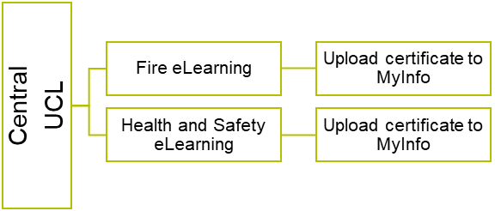

Goes to supervisor for DSE assessment

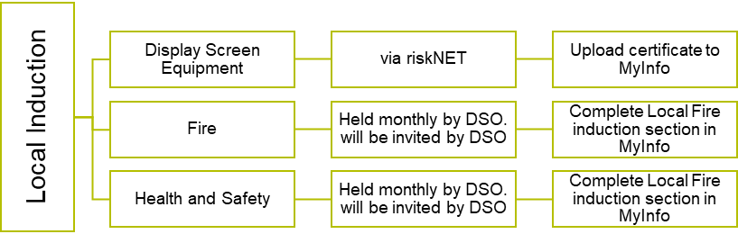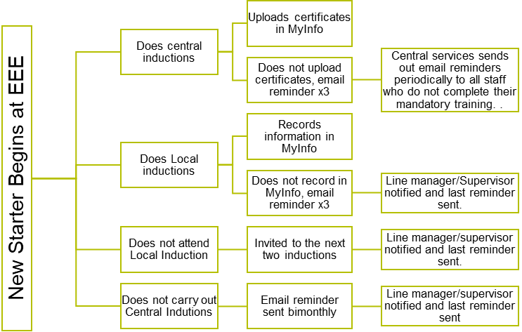

Access is removed, for PhD student’s tutor’s will be notified and for staff their line manager will be notified.

Access will be reinstated if inductions are completed.

All inductions are important and a condition of working at UCL as they inform the health and safety and wellbeing of the new starter. Please note the timeline below and what occurs in the event of the inductions not being carried out. It is tracked in MyInfo.

Safety inductions are mandatory for all UCL New Starters. They contain essential information to help them become aware of the central and local arrangements for their health, safety and well-being including any safety procedures that that are specific to their job and/or areas of work. All new UCL staff, graduate research students, contractors and visitors who will be here for >1 month, undertaking work at UCL, must do the online central inductions and receive a local safety induction. It is the responsibility of the line manager, principal investigator (PI) or supervisor of the new starter to ensure the completion of the safety induction process

Timeline: Month 1 Month 2 and 3 Month 4

**DEPARTMENT OF ELECTRONIC AND ELECTRICAL ENGINEERING**

**TRAINING AND INDUCTION PROCEDURE**

